REQUIREMENTS FOR THE CONTEST 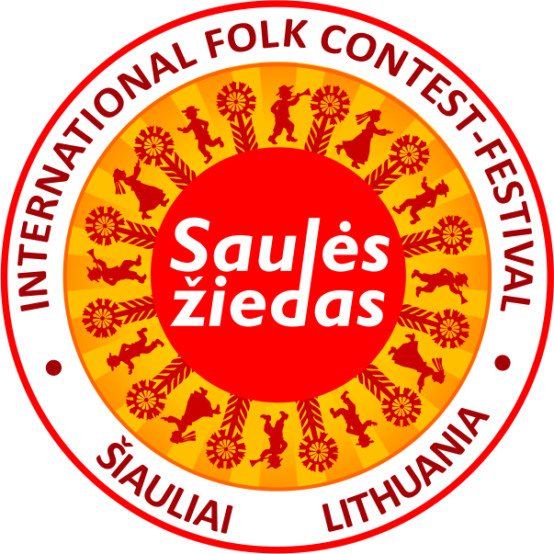

I Category: TRADITIONAL FOLK DANCE GROUPS
Number of dancers: 8 to 16. Plus up to 12 others, including musicians/flag bearers.
Age limit: 17 years and over.
Duration of the contest performance: up to 12 min. total.
At least two dances. The sources of origin should be indicated in the application.

II Category: CHOREOGRAPHED ARRANGEMENTS OF FOLK DANCES
Number of dancers allowed: 8 to 16. Plus up to 12 others, including musicians/flag bearers.
Age limit: 17 years and over.
Duration of the contest performance: up to 12 min. total.
Two choreographed dances or one dance composition. The authors of music/arrangement and choreography should be listed.

III Category: INSTRUMENTAL FOLK MUSIC ENSEMBLES
Number of musicians allowed: 3 to 12.
Age limit: 17 years and over.
Duration of the contest performance: up to 10 min. total.
The ensembles should perform the instrumental traditional music of their country or region. The sources of the performed pieces should be indicated in the application.

IV Category: ENSEMBLES OF TRADITIONAL SINGING
Number of singers allowed: 3 to 12. Age limit: 17 years and over.
Duration of the contest performance: up to 8 min. total.
Two traditional one-part or two-part songs.
The instrumental accompaniment is allowed if it is characteristic of the tradition (the piano/grand piano excluded).
The performance of the accompanists will not be evaluated by the jury or awarded. The sources of the songs should be indicated in the application.

V Category: FOLKSONG SOLO
Age limit: 17 years and over.
Duration of the contest performance: up to 8 min. total.
Accompaniment is allowed if ft is characteristic of the tradition (the piano I grand piano excluded). The soloist may accompany himself/herself. The performance of the accompanists will not be evaluated by the jury or awarded.
The sources of the songs should be indicated in the application.

VI Category: INSTRUMENTAL SOLO
Age limit: 17 years and over.
Duration of the contest performance: up to 8 min. total.
Traditional tune(s) of the competitor’s own country should be performed by a single player on one or several traditional instruments.
The sources of the tunes should be indicated in the application.

